What is Marketing?
To me, marketing is connecting the right customer to the right product. Sales is seeing if that makes sense right now. Marketing is everything happening between a prospective consumer and the product. It’s creating awareness, building trust, creating demand, understanding problems and pain points, creating streamlined processes and systems to funnel into sales. Different companies have different angles of attracting the right customers. Understanding these angles and innovating to create a unique strategy is crucial. Creating a brand through a unique voice, and aligning all the different channel strategies to that voice will create a cohesive brand image. It’s not about knowing how to create a good ad, but researching demand.
At the end of the day, I believe marketing is about manifesting happiness in a chaotic world; happiness that manifests in the experience of buying something. Going to a nice restaurant to treat your family and take a break from the world. Buying a piece of jewelry because life is short and we want to look beautiful every day. Buying debt relief because we are tired of being that person who is defined by struggle. Happiness manifests itself in the end product of anything we sell. When we engage in a project, we must always keep the end in mind. What is it we actually want to accomplish? Respice finem (remember the end).
Our Approach
First, we need to understand that every business and every market is different. The world is also constantly changing. To execute any successful project, we need to understand that every project will contain some variation of a research stage, an analysis stage, and then an action (or decision that must be made). Every project will have similarities in structure and frameworks, but every project will also be different based on the client’s needs, the business, the industry, and the market. Our core mission is to better understand people, markets, and businesses so they can make better decisions.
Different Services Provided by Marketing Agencies
At the core, a marketing agency boosts business potential by developing targeted strategies, running data-driven campaigns, and optimizing brand reach and reputation. They cover a variety of services, from digital marketing to creative content, to transform the marketing trajectory of any business.
- Digital marketing
  - Inbound marketing and demand generation
    - Market research
      - Understanding consumer behavior, industry trends, and competitor strategies
    - Content marketing
      - Blogs
      - Videos
      - Podcasts
      - Infographics
      - Social media posts
      - Case studies
    - Strategy development
    - Analytics & reporting
    - Conversion tracking
    - Competitor audits
    - Paid advertising (PPC)
    - Search engine optimization (SEO)
    - Custom landing pages
    - Conversion rate optimization
    - Ad copywriting
    - Remarketing
    - Ongoing optimization
  - Outbound marketing
    - Cold calls
    - Email campaigns
    - Linkedin messaging

- Content creation
- Brand development
  - Creating a clear brand identity and positioning
- Web design
  - Custom web design
  - Logo design
  - New technologies
  - Content strategy
  - Product & service pages
  - UX & UI design
  - Mobile responsiveness
  - On-page SEO
  - Conversion rate optimization
  - Website analytics
  - Ongoing website maintenance

Know the Difference
Efficiency: creating as little waste as possible. Input to output ratio is low. Like a Toyota’s gas mileage. It creates little waste with high return in gas usage.
Optimization: creating efficiency towards a specific goal. A Ferrari is not efficient in the traditional sense because it creates a lot of waste. The input to output ratio is high for gas mileage. But, it is optimized for speed, luxury, and performance. There were tradeoffs made, variables changed, that may make it less efficient in one sense but more optimized in another.
It’s important to know the difference between efficiency and optimization because it is our job as marketers to generate optimal leads for the sales team, so that they can work more effectively towards their goal. For example, if we sell them 100 leads that close at 5%, we may be wasting ours and their resources. Instead, selling them 50 leads that close at 15% would actually be more optimal for us and them. We need to be highly selective with which leads we are generating for them. Expect to turn down leads that do not fit the criteria that we lay out.
Definitions:
Organic traffic refers to visitors who land on your website from unpaid, “organic” search engine results (like Google) rather than through paid advertisements. It is earned, not bought, primarily through Search Engine Optimization (SEO) and high-quality content. This type of traffic is high-intent, sustainable, and cost-effective.
Lead generation is a subset of marketing focused on short-term, measurable goals – specifically capturing contact information of qualified leads to build a sales pipeline. Marketing aims for long-term growth and brand positioning.
Creatives in marketing are the tangible, artistic, and conceptual materials used to communicate brand messaging, garner attention, and drive user engagement or action. They are the actual advertising assets. Common formats include display banner ads, social media posts, videos, email design, interactive content, static images, carousel ads, infographics, and more.
Copy refers to the written text used in advertisements, websites, emails, and promotional materials designed to persuade, inform, or prompt a specific action from the audience. Unlike general content, copy focuses heavily on driving conversions and engaging with a brand.
CPC (Cost Per Click): Cost-per-click is a pricing model where advertisers are paying for every time someone clicks on your ad. If you spend $2000 on CPC and get 1,000 clicks, your CPC is $2. This model is used to drive traffic directly to a website. It is a primary component of PPC marketing. Total cost/Total clicks = CPC
CPM (Cost Per Thousand Impression): Cost per thousand impressions is a pricing model where advertisers are paying for the number of times an ad is shown, regardless of whether it is clicked on or not. This model is only really used to spread brand awareness. (Total cost/Total impressions) x 1000 = CPM
CTR (Clickthrough Rate): Clickthrough rate determines how well your advertisements are performing. It measures the number of clicks that your ad receives divided by the number of times your ad is shown: Total clicks/Total impressions = CTR
CPA (Cost Per Action, or Cost Per Acquisition) – Cost per action is a pricing model where advertisers pay only when a specific, predefined action is completed by a user – such as a purchase, form sign-up, or app download. This model ensures ad spend is directly tied to conversions, minimizing risk compared to models based on clicks or impressions. Total Cost/Number of Conversions = CPA
ROAS (Return on Ad Spend) – critical marketing metric measuring revenue generated for every dollar spent on advertising. Revenue from Ads/Cost of Ads. Indicates campaign efficiency and profitability. Common average is 2:1, but a good ROAS depends on profit margins, with many targeting 4:1 or higher.
For digital marketing and generating leads, we have to ask ourselves “where online does our target audience live?”
Campaign - first thing we create. Defines campaign type and main objective (what we are selling)
Ad set - defines who we are targeting and how we are targeting them. We may have multiple ad sets in a campaign to test different audiences
Ads - Creative material in an ad set that we use to reach an audience and talk about our offer.
Campaign -> Ad set -> Ads
- For social media ad campaigns (like Meta), it is best to have 3-5 ad sets per campaign. Within each ad set, you can have 3-6 ads. This way, you can test creatives, audiences, or placements to optimize your budget.
Strategy -> The why behind a decision; a position on something. The thinking that guides the action. For example: In chess, you may have a plan. The plan is to move your knight, then your bishop, then your Queen. Those are the clear steps, or the plan, to take. So, the plan is the what. The strategy would be that you are moving those pieces that way because you want to corner their king or draw out their rook.
In battle, the strategy may be to take out certain strongholds in the mountains because then it cuts their supply and draws troops out from the east. The plan is the actual steps it takes to do this: move cavalry up, bring infantry to the right, and march straight in.
So, in business, the strategy is the WHY and the WHERE. The plan is the WHAT, as a result of strategy.
Operation is HOW the plan will get done; the intricate day-to-day operations of a plan.
So, in my philosophy, it goes strategy -> plan -> operation. These levels must be aligned.
What are tactics then? Tactics are on-the-fly, short-term, or mid-range adjustments to the plan because of new information or change to the strategy that can optimize operations better. For example, we find that in our sales CRM, automation might help on a certain level of prospecting. Without really disrupting strategy, we can employ this tactic to help improve the operation and hence growth.
Data is raw information. Simple observations.
Data analysis is taking loads of data and cleaning it, organizing it, and querying it to find trends, patterns, or significant points. Questioning and frameworks are key to analysis. Ultimately, data analysis is the work (processing the data) so that it may be understandable and ultimately presented. We can present data through data visualization and reporting to make it digestible.
Business insights then, are actionable conclusions drawn from analyzing data, designed to help organizations understand, improve, and strategize their operations. Insights translate raw data and data analysis into “aha” moments that reveal patterns, trends, and customer behaviors, enabling better decision-making to gain a competitive advantage. What do the trends mean? How can we connect this analysis to a broader narrative and other analyses? Business insights are extremely valuable and where we can position ourselves long-term. Business insights supply businesses with better, more affordable equipment to prepare for these conditions ahead of time.

So, data is first observed and collected -> data analysis includes a summary of the data, points out key trends or patterns, as well as some possible causes and factors at play (we derived from frameworks and questioning) -> an insight is produced as a summary of that analysis in a succinct position that is then turned actionable. Frameworks are again also important here and at every step to ensure excellent results.

Data —--------------> Data Analysis —-------> Insight
Raw observation -> Detailed description? -> Why did it happen and what do we do about it?
Data analysis is the work, but insights are what is actually valuable and what companies pay attention to.

Ad Strategy:
ABO -> Ad Set Budget Optimization
- You manually set the daily budget for each ad set. You use ABO when you care about the performance of each ad set individually and set a budget for each.
CBO -> Campaign Budget Optimization
- You set a daily budget for an entire campaign and Meta’s algorithm will give the lionshare of the budget to the ad that is performing the best (highest ROAS or CPA)

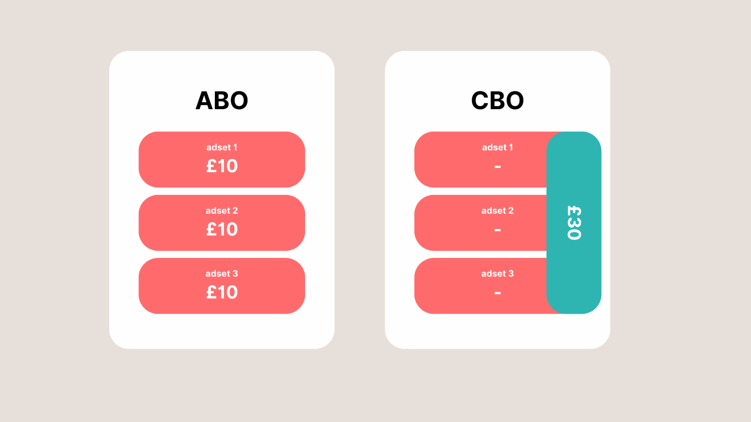

Brand Strategy (taken from Timothee Chalamet):
Great rule of thumb for content split (taken from Timothee Chalamet’s personal brand content split):
- 60% work
- 30% process
- 10% personal

Full-funnel advertising:
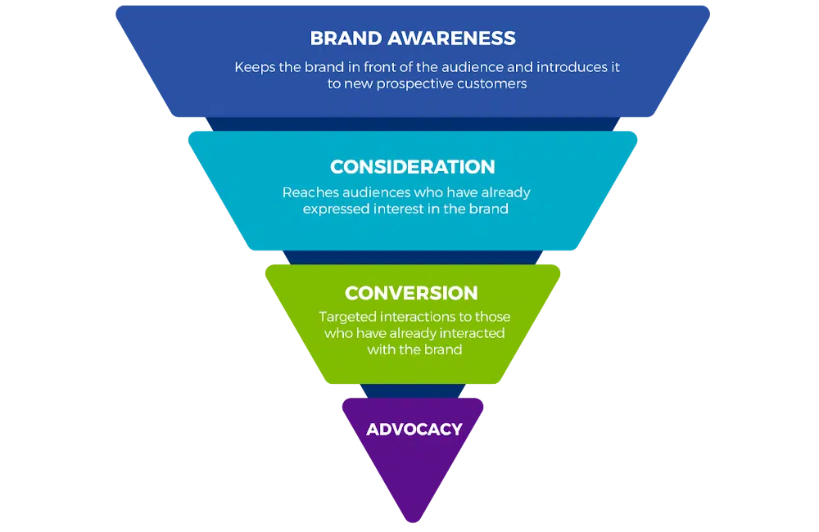

Digital Marketing Strategy
- Boils down to research and understanding; how you frame things. Define these three things before moving forward:
  - Audiences and avatars: who cares, or who do you want to care?
  - Value prop & differentiators: what makes them care or at least pay attention?
  - Competition: who/what is in the way of your goals, and how are they doing it better than you?
- Don’t worry about figuring out strategy for each channel yet. Right now you need to build your strategy at the highest level. KPIs, channels, all of it needs to wait. Key metrics and individual points should be defined based on strategy, not strategy based on key metrics.
- Once you have those three foundational elements, you can start to move toward strategy. Start with understanding if you are targeting brand positioning, growth, or demand. All three come into play when you are looking at a high level strategy, regardless of where the company/client is in the lifecycle:
  - Early life: 60/30/10 positioning/growth/demand
  - Decently established: 40/50/10 positioning/growth/demand
  - Well-established: 20/40/40 positioning/growth/demand
- After understanding what you are prioritizing in terms of overall goal, then you can start looking at campaign-level things like channels, creative strategy, and KPIs.

Key Takeaways from https://mthdmarketing.com/blog-posts/marketing-agency-pricing
- Small businesses spend $2,500-$7,500 monthly
- Mid-market companies spend $7,500-$25,000 monthly
- Enterprise organizations spend $25,000-$100,000+ monthly
- Project work ranges from $5,000-$50,000+
- Most agencies lock you in for 3-6 months minimum

My breakdown of end-to-end marketing services (the full stack):
Strategy Development:
- Market research and analysis
  - Understanding the company, the consumer, the competitors, and the industry (trends)
  - Developing business insights
  - Developing or finding useful frameworks for strategy (like SWOT and many others)
- Figuring out who your customers are
  - ICP and Buyer Personas
- Figuring out where your customers are
  - Deciding which channels to focus on
  - Where do the customers live online?
- Figuring out what content to show and distribute to customers. What do they care about? It could be educational, authoritative, or community-based
  - Content strategy
    - Research
    - Key messaging and creative
    - Topics, headlines, etc.
    - Formats
    - SEO
    - Distribution
- Brand development
  - Assessing current brand vs. brand you want to be
  - Brand assets and brand identity
  - Guidelines
  - Strategy
  - Revisions and iterations
  - Brand rollout
- Setting goals and deciding what to measure - defining success through KPIs

Planning campaigns (in a nutshell)
  - Research and analysis (SWOT analysis)
  - Defining target audience (ICP and personas)
  - Goal setting - increasing brand awareness, launching a product, generating leads, etc.
  - Messaging and Creative - developing key messages that resonate with pain points and emotions
  - Channel selection
  - Budgeting and resourcing - allocating funds for content creation, ad spend, and tools
  - Timeline and scheduling for launch, testing, and completion
  - Measurement and KPIs
Campaign Creation:
- Ad creative (images, video, copy)
  - Copywriting
- Content creation - posts, whitepapers, articles, podcasts, interviews, etc.
- Web Design and Development
- Custom landing pages that convert
- Email campaigns
- Social media content
- SEO content and keyword research (on and off page)
- LinkedIn messaging
- Email campaigns
- Physical campaigns (events, sponsorships, flyers)
Execution and Management
- Launching campaigns
  - Creating and scheduling blog posts, social media updates, and email campaigns according to a content calendar
- Technical implementation
  - Setting up landing pages, configuring tracking tools like Google Tag Manager and ensuring CRO
- Social media management
  - Engage with audiences, reply to comments, DMs, messages, etc.
- Paid ad management
- Website management
- Performance optimization
  - Daily monitoring and tweaking by analyzing data from platforms like Google Analytics to
    - Adjust budgets, manage paid ads (media execution), and manage bids
    - Test creatives (A/B) testing and improve ROI
Analytics and Reporting
- Tracking performance
  - Social media analytics and reporting
  - Conversion tracking
- Ongoing optimization
  - Conversion rate optimization
- Web analytics
- Google analytics
- Monthly or weekly reports
- Strategy sessions to review what’s working and what’s not working
- Remarketing
- Recommendations for what to do next
- Attribution analysis

Account Management
- Resource and timeline management
- Rounds of iterations and feedback before launch
- Regular check-in calls
- Email and phone support
- Strategic guidance
- Coordination with our team
- Fixing issues when they come up

Ultimately, you are paying a marketing agency for their thinking, for their perspectives. That’s why it is so important to continue to push boundaries, think outside the box, and be an inventor. Boldness cannot be replaced, no matter what big tech says. The world is not figured out. It is as nuanced as ever. That is where the opportunity is.
So, full stack, end-to-end marketing service includes strategy, creation, implementation, and analytics/reporting. Fees include everything in those 4 stages.

Or, we could do just by service type:

Web Design and Development
Range: 5-50k per project
What affects the price:
- How many pages and how complex
- Custom design versus tweaking a template
- E-commerce features
- Custom functionality or integrations
- Whether copywriting is included
- How fast you need it
Paid Advertising Management
Range: 1-10k plus a percentage of ad spend
What affects the price:
- How many platforms (Google, Meta, Linkedin)
- How complex the campaigns are
- How much you’re spending on ads
- Whether they create ad creative
- Landing page optimization

SEO Services
Range: 1.5-10k a month
What affects the price:
- Local vs. national campaigns
- How competitive your keywords are
- Technical work needed
- How much content creation
- Link building scope

Social Media Management
Range: 1-5k monthly
What affects the price:
- How many platforms
- Posts per week
- Community management level
- Content creation (video, graphics, photos)
- Paid social advertising
Content Marketing
Range: 2-15k monthly
What affects the price:
- How many articles or pieces
- How long and detailed
- Research and expertise required
- Distribution and promotion
- SEO optimization level
Email Marketing
Range: 500-5k monthly
What affects the price:
- How many campaigns
- List size and segmentation
- Design and copywriting needs
- Automation complexity
- Strategy and testing level
Video Production
Range: 2-25k per video
What affects the price:
- VIdeo length and complexity
- Production quality and location
- Talent and crew needs
- How sophisticated the editing is
- Usage rights and licensing
Branding and Identity
Range: 10k-75k per project
What affects the price:
- Scope (just logo versus complete brand identity)
- How deep the strategy goes
- What deliverables you need (guidelines, templates, assets)
- Revisions and iterations
- Brand rollout support
Kickstarter Campaign Management
Range: 15-50k per campaign
What affects the price:
- Campaign strategy and planning
- Video production needs
- Page design and copywriting
- Pre-launch marketing
- Managing the live campaign
- Post-campaign fulfillment planning

LEAD GENWatch This To Generate 1000s of Leads (In Any Niche)(Notes)
- Most people send traffic to their website and immediately ask them to buy something (basic CTA)
  - Most people are not ready to buy yet so they just leave
- If you don’t have as much traffic as an established brand, then a basic CTA does not work. You need to provide value first. The objective is LEAD CAPTURE
  - Provide a mini offer - a mini solution to a narrow problem to see who is interested
  - The mini offer reveals another problem that is solved by the core offer
  - This is also known as a lead magnet
- Steps to create an effective lead magnet:
  - Figure out the problem you want to solve and who to solve it for
  - Figure out who to solve it
  - Figure out how to deliver it
  - Test what to name it
  - Make it easy to consume
  - Make it very good
  - Make it easy for them to tell you they want more
- Lead magnets are not going to get more traffic, but it will dramatically improve conversion - more profit with no additional cost
- Test the wrapping of the lead magnet - test headlines. As long as content solve the problem for the person, then it is really how we package it
- Types of lead magnets
  - Sample, or Free Trial (might work for food)
    - Think of Costco food example, or free agency services for 4 months example
  - Step 1 of many, or Reveal a Problem (might work for fashion or even debt relief)
    - Works for more complex services. Definitely would be good for debt relief
  - Free assessment (free website speed test -> uncover that website is slow -> core offer is boosting website speed) this would also work for debt relief
    - When you reveal a problem for them, also show them what it would be like if they did change. Debt is a problem that is only going to get worse. Show them what they can do with extra funds and being debt free
    - When you reveal a problem, BE SPECIFIC. It builds credibility that you have a solution rather than just promising something
- Make a dropdown menu to qualify leads or not (direct traffic to qualified leads to debt relief and unqualified ones somewhere else)
- Make sure the person is deprived of the thing that we sell, then trigger that deprivation in our lead magnet

We now know what a lead magnet is, why it matters, and the different types. How do we implement them?
- Software/Tools that are given to the consumer to do a mini job for them
  - Spreadsheets
  - Assessment Tools
  - Templates
  - Software
  - On the back end, we need the tool to assess, answer a question, or complete a job for them. Collect info on the back end.
- Information - teach them something valuable. It’s infinitely scalable,
  - Mini courses
  - Guides
  - Interview with experts
  - Case studies
- Services - do work for free. Create good will. Do free work for people that are QUALIFIED. Do not waste time on unqualified leads.
  - Free audits
  - Labor
  - The right people will stay and pay if you do a good job
- Physical products

You can combine these categories and make your own lead magnet tools. The bottom line is to get qualified leads and provide value to them before they buy anything.
Name your lead magnet the right way. Poll your audience if you don’t have the money to A/B test headlines.
Some templates:
- [Number] + [Outcome] + [Timeframe]
- How to [yay] w/o [boo] even if you [insecurity]
- The [adjective] [type] that [benefit]
- X mistakes that prevent [Good]
So now, we know what a lead magnet is, how to implement it, how to name it. Now, how do we get leads? Well, now you need a CTA. This is where most people stop or don’t do it often enough.
The salespeople that ask the most times get the most deals
Maximize your ability to ask by giving more value between asks.
Make your CTA
- Is CLEAR AND DIRECT
- Has NEXT STEPS
- Reason to DO NOW

Know your capacity limit and leverage it as scarcity based on existing small constraints. People do not know how big your business is or how much you can take on.
Ultimately, the spirit of the lead magnet is to provide value first. MAKE SURE YOU EMBED CTA AS MANY TIMES AS YOU CAN WITHIN A LEAD MAGNET.

SEO BASICS
- The google search engine helps people discover your content. SEO - search engine optimization - is about helping search engines understand your content, and helping users find your site and make a decision about whether they should visit your site through a search engine.
- Effects of any change can take some time until it is reflected on Google’s end - anywhere from a few hours to a few months. So it is good to wait a few weeks to assess whether the work was beneficial.
- Programs called crawlers explore the web constantly, looking for pages to add to Google’s index.

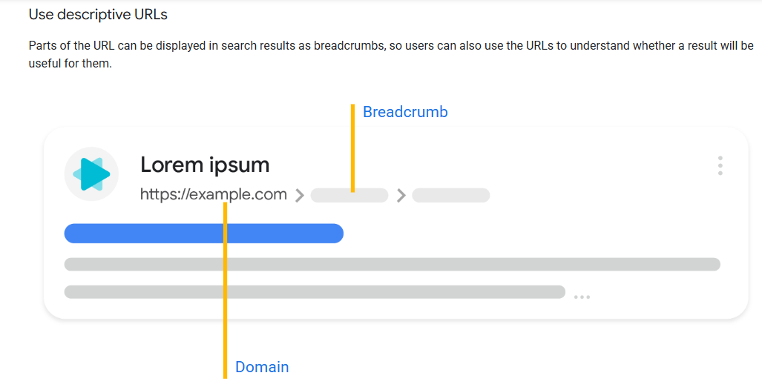
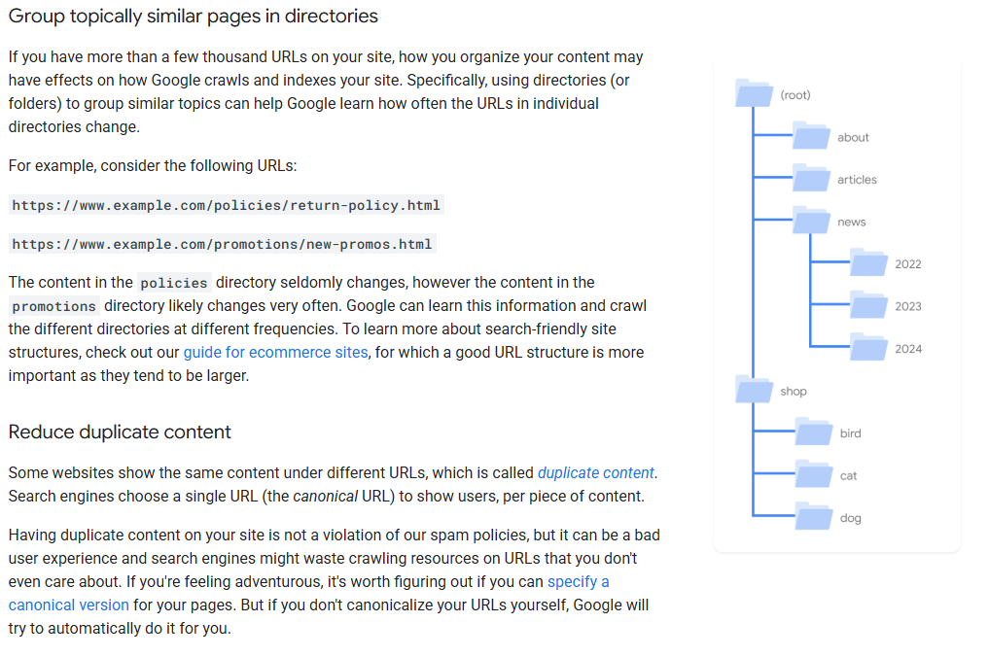

- Make your site interesting and useful
- Create content that is unique
- Make sure the content is up to date and relevant
- Make sure the content is helpful, reliable, and people-first
Expect your reader’s search terms. Anticipate what a user might search for and understand their search behavior
SMART goals are goals that are
- Specific
- Measurable
- Achievable
- Relevant
- Time-bound

Here are different types of SMART goals for marketing:
Content Marketing & SEO
- Boost Organic Traffic: Increase blog organic traffic by within six months by publishing two high-quality SEO articles per week, as discussed on the Pepperland Marketing blog.
- Improve Search Ranking: Rank on the first page of Google for 5 target keywords by optimizing existing content over the next four months, as discussed on the Pepperland Marketing blog.
Lead Generation & Sales
- Increase MQLs: Boost Marketing Qualified Leads (MQLs) by by the end of Q2 by launching a new targeted LinkedIn ad campaign, as discussed on the Pepperland Marketing blog.
- Boost Conversion Rate: Increase the website lead conversion rate from to by updating the contact form and landing page design by June 30th, similar to goals on the Pepperland Marketing blog.
- Grow Email List: Grow the email subscriber base by (an additional 500 subscribers) within two months by launching a new whitepaper download, as suggested on the Smartsheet website.
Social Media & Brand Awareness
- Boost Engagement: Increase Instagram engagement rate by over the next 90 days by posting daily interactive content (videos/polls), as discussed on the Pepperland Marketing blog.
- Grow Followers: Increase total social media followers across all platforms by by the end of the year through increased influencer partnerships, similar to strategies mentioned in a Reddit post.
Email Marketing
- Improve Open Rates: Increase email newsletter open rates from to by the end of Q3 by testing and optimizing subject lines.
Customer Acquisition
- Reduce Cost Per Acquisition (CPA): Decrease CPA by in the next six months by optimizing Google Ads targeting and ad creative, as suggested by the Pepperland Marketing blog
Components of a SMART Goal
- Specific: Clearly define what needs to be achieved.
- Measurable: Choose a number (e.g., more, ).
- Achievable: Set realistic goals based on resources.
- Relevant: Align with wider business objectives.
- Time-bound: Set a specific deadline.

Core Mission Statement Templates
- Standard Formula: To [contribution/goal] so [impact].
- Comprehensive: Our mission is to [primary purpose] for [target audience] by [how you achieve it].
- Action-Oriented: To [what you offer/how you do it] for [target audience] to [contribution/goal] and [impact].
- Concise (8 words or less): [Verb] [target population/setting] [outcome/measurement].
- Personal Mission Formula: To [what you want to achieve/do] so that [reason why], by [specific behaviors].
Key Elements to Include
- Purpose: What do you do?
- Method: How do you do it?
- Target Audience: Who do you do it for?
- Impact: What is the ultimate outcome?
Examples using the Templates
- Asana example: "To build [what you offer] and [contribution/goal] so [impact]".
- Spotify example: "Our mission is to [unlock the potential of human creativity]—by [giving a million creative artists the opportunity to live off their art]".
Tips for Writing
- Keep it simple: Avoid corporate jargon.
- Make it actionable: Use strong verbs (e.g., "to empower," "to build," "to connect").
- Seek feedback: Refine the draft with your team to ensure it represents your values.

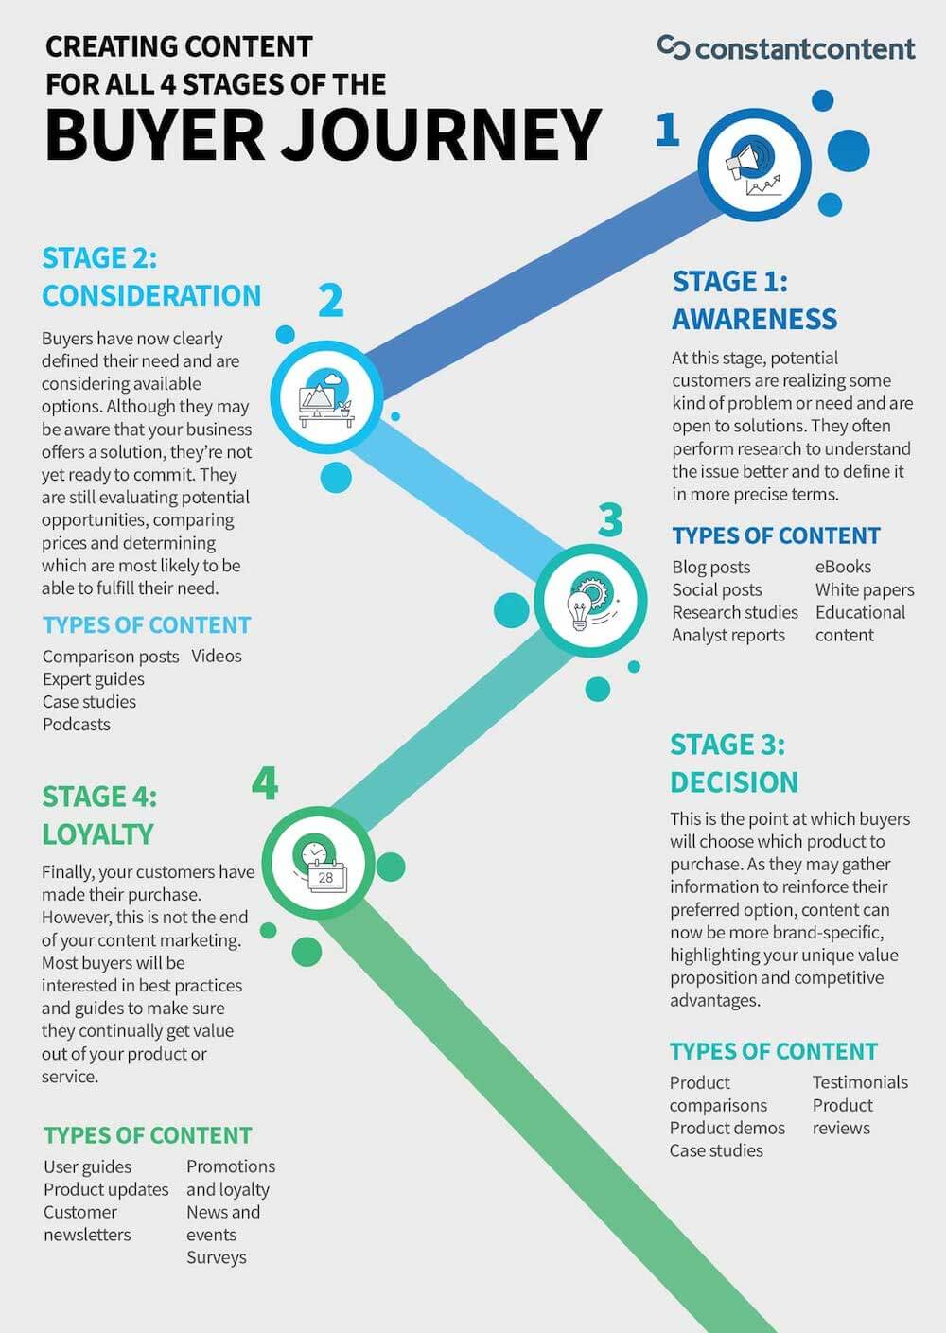
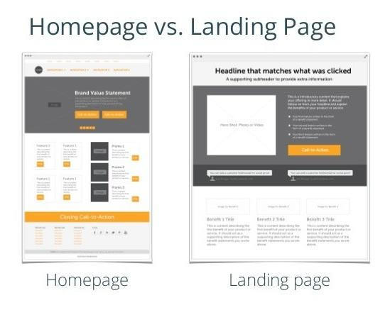

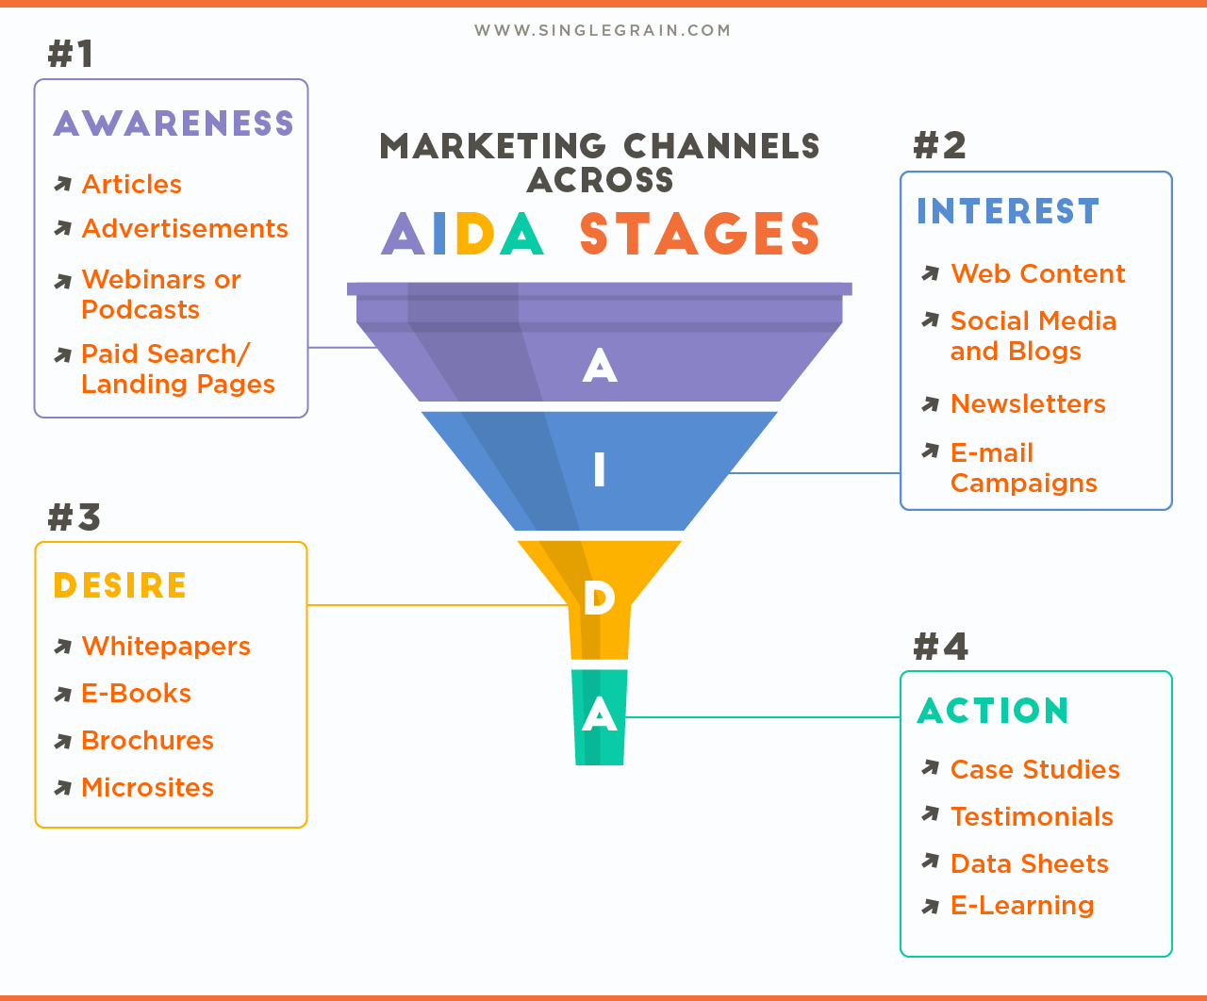

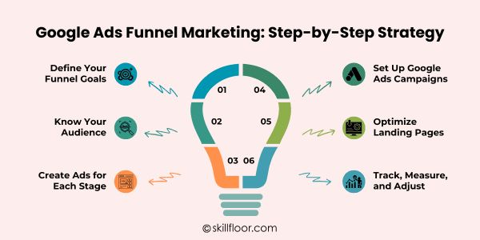

Helpful Sources:
- What do marketing agencies do: https://www.wearetg.com/blog/what-does-a-marketing-agency-do/#:~:text=What%20Does%20a%20Marketing%20Agency%20Do:%20Your,ensure%20alignment%20with%20business%20objectives%20and%20budget.
- https://www.youtube.com/watch?v=c07Q2ihrq_k
- https://mthdmarketing.com/blog-posts/marketing-agency-pricing

